HFR BULK UPLOAD

HFR bulk upload can be done by facility manager to onboard multiple facilities in HFR portal.
The facilities onboarded by the facility manager, will reflect on facility managers dashboard. All these facilities will be owned by the respective facility manager. Once the facility is registered, this facility will reflect in the respective verifier’s login for verification.

Facility manager will open the portal and click on bulk upload button, then user must select the type of facility for which the bulk upload has to be done. There are 4 bulk upload formats mentioned below.
- Hospital Clinic CHC PHC HWC SC - For onboarding the hospitals, clinics, Community health centres (CHC) , primary health centres(PHC),Health and wellness centres (HWC), Subcentres(SC) and medical colleges.
- Diagnostic Laboratory and Imaging Centre – For onboarding Diagnostic Laboratory and Imaging Centre
- Pharmacy - For onboarding pharmacies
- Blood Bank - For onboarding blood banks

Portal link- https://facility.abdm.gov.in/

Note: - 100 facilities can be onboarded on in a single go.

Step by Step process for Bulk Upload

Step 1: Login in the portal by facility manager id. (https://facility.abdm.gov.in/)

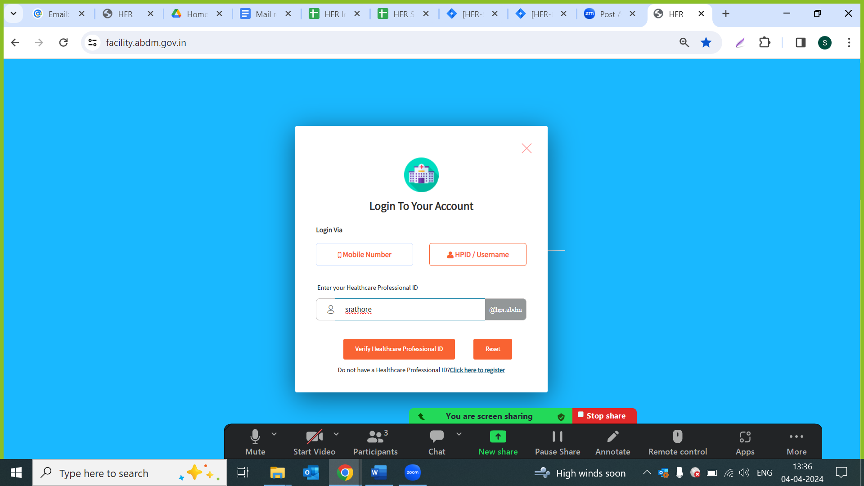

Step 2: Click on “Add Facilities in Bulk” button.

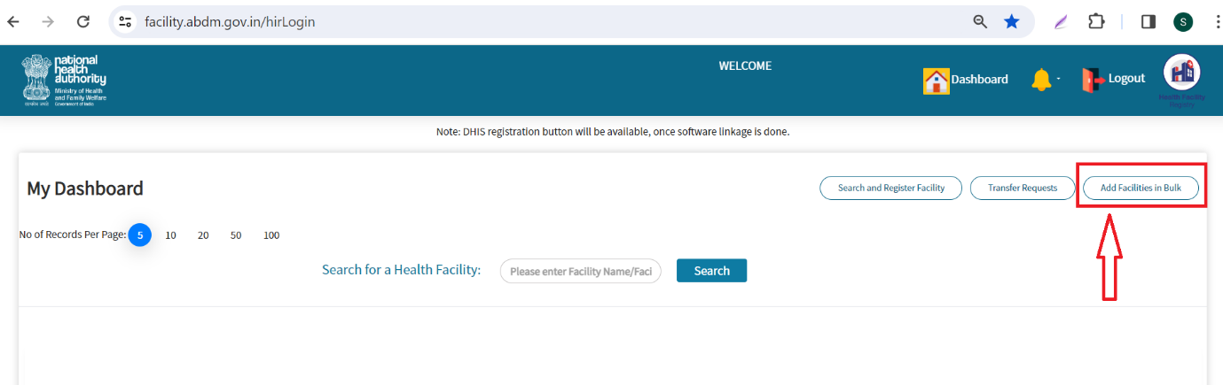

Step 3: Select the facility User must select ‘Facility Type’ from the dropdown and then click on Download Sample File

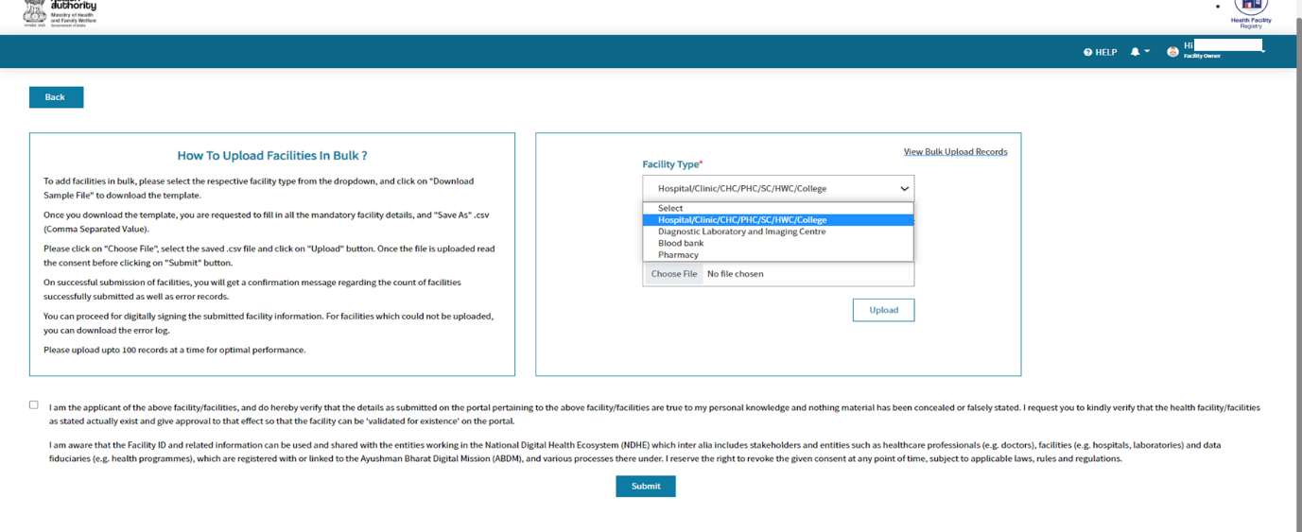

Step 4: Open the downloaded sheet, read the instructions carefully and fill the sheet accordingly.

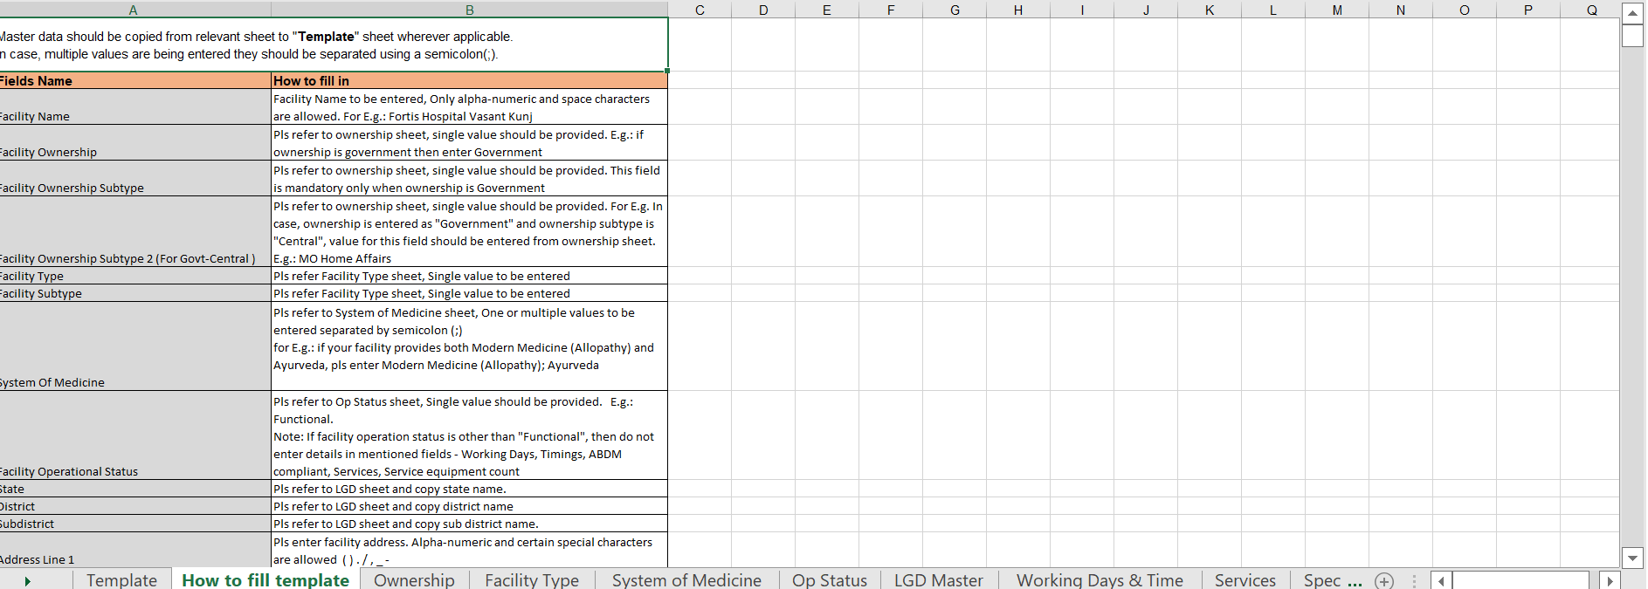

Step5: After filling the sheet click on “choose file” button to upload the sheet. Select the file and click on “Upload button”

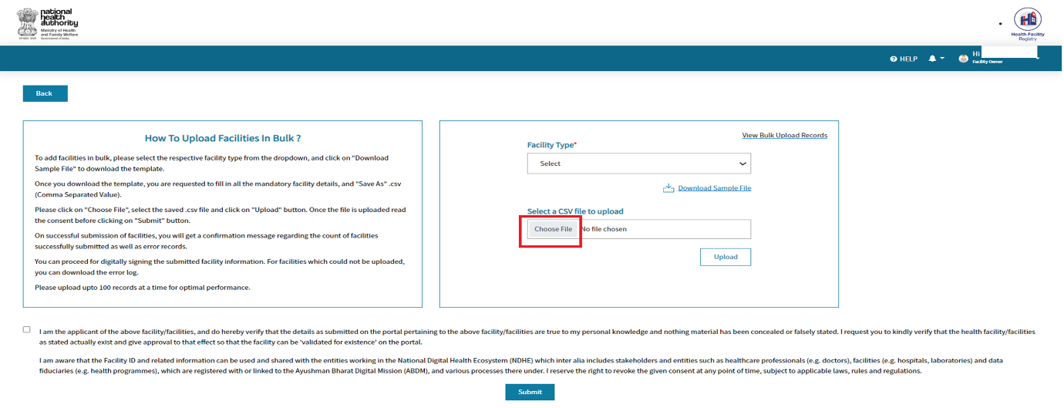

Note: - While uploading user has to select the same ‘facility type’ in dropdown, for which the details has been added in the excel. Also excel show be in comma separated format.

Step 6: Click on the checkbox and press the submit button.

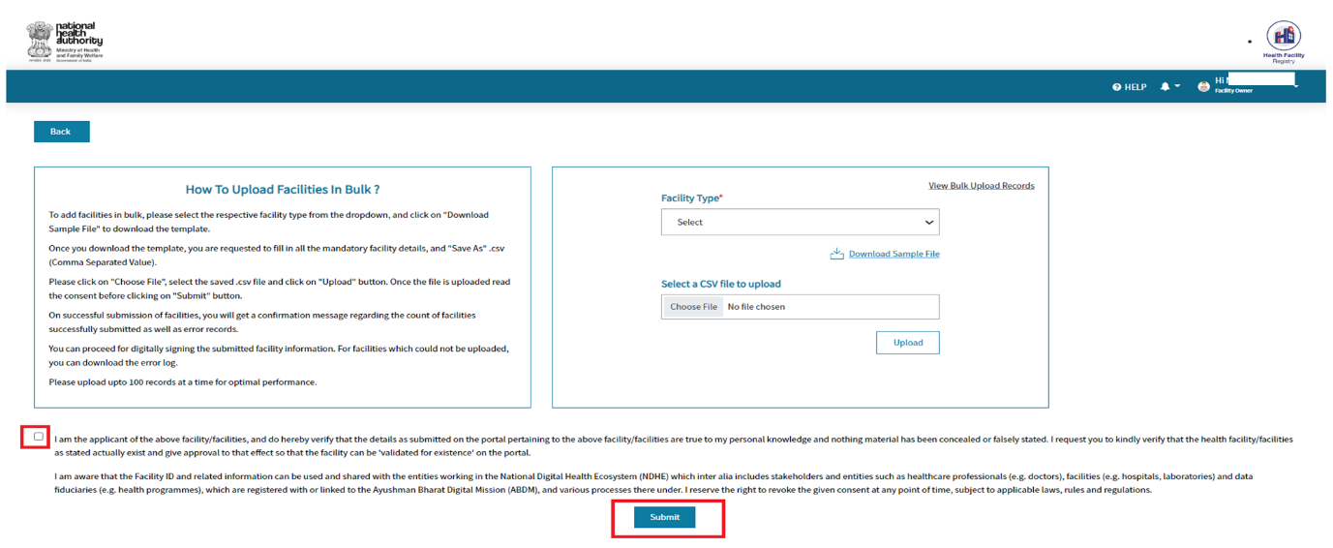

Step 7: On the click of ‘Submit’ button below screen will come.

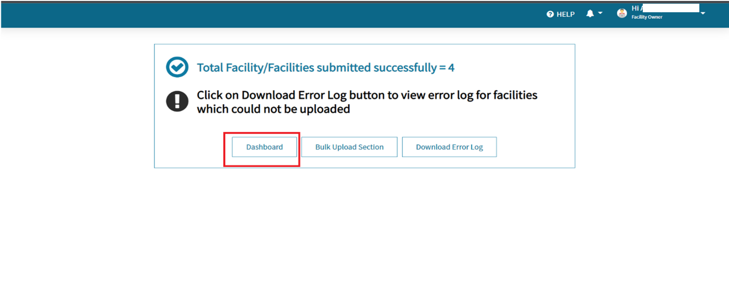

- If the facility upload is successful, then user can click on “Dashboard” button and go back to facility dashboard.
- If the facility upload is failed, then user can click on “Download error log” button and can download the excel along with the failure reason.
- If user wants to move back to bulk upload screen, then user needs to click on the “Bulk Upload Section.”

Step 8: Download the error log file with Remarks column needs to be corrected for the failed facilities.
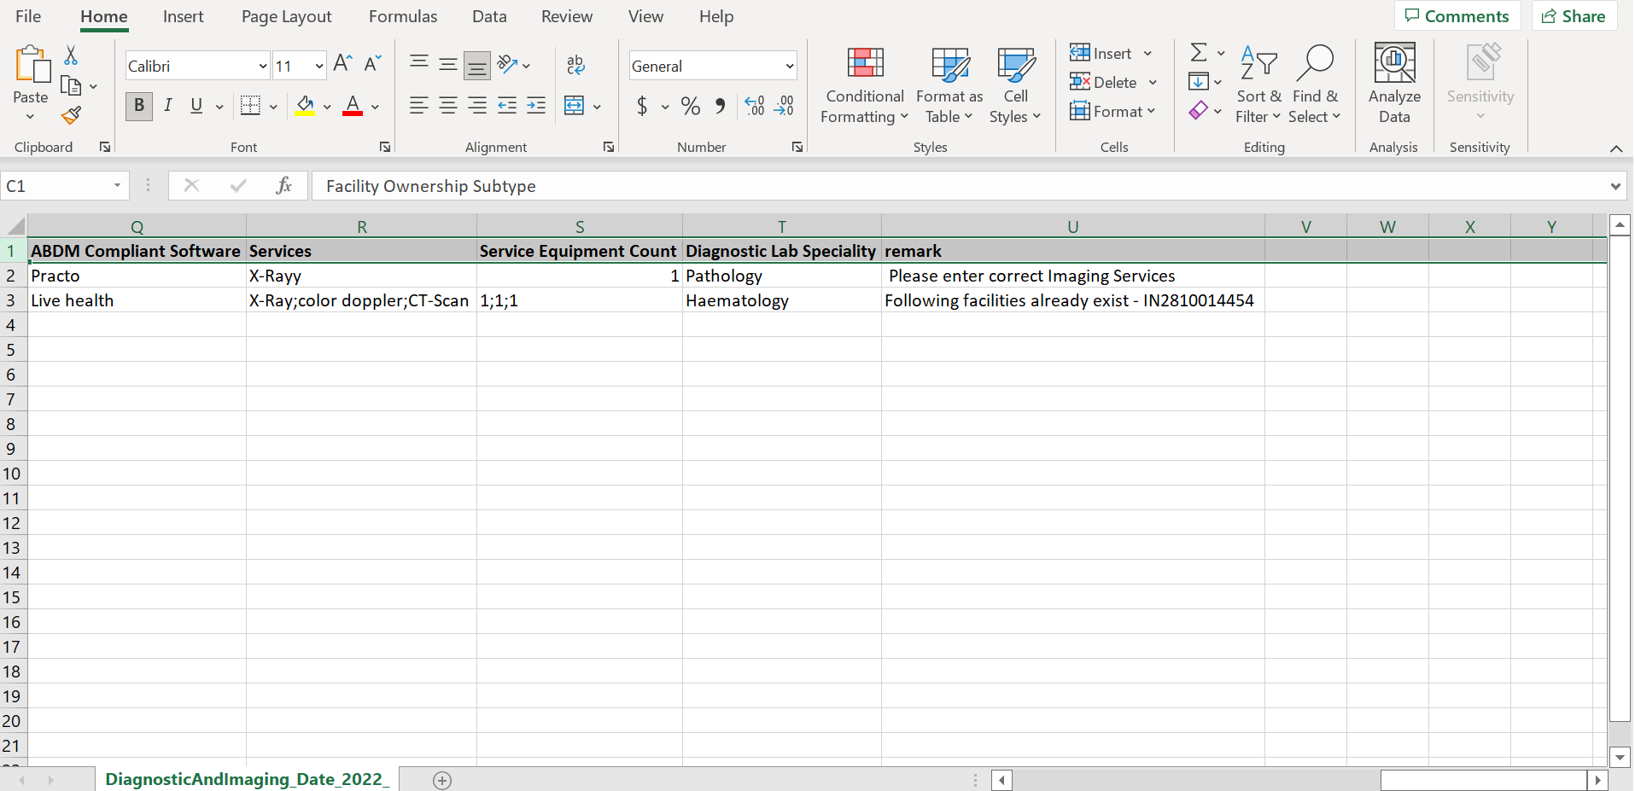

Note: - After the corrections, user must upload the sheet again in CSV format.
After successful bulk upload user can e-sign all the facilities.

Step 9: Once the facilities are submitted user can go back to facility manager dashboard and view all the registered facilities.

